**M S Ramaiah Institute of Technology**

(An Autonomous Institute, Affiliated to VTU)

MSR nagar, MSRIT post, Bangalore-54

A Literature Survey on

**Smart Health Care Monitor Using Raspberry pi 2.**

Under the guidance of

Mrs. S. Rajarajeswari.

Submitted by

Himanshu Kumar 1MS12CS039

Suhail T N 1MS12CS115

Manoj more S 1MS13CS412

Suresh V 1MS13CS421

*In partial fulfillment for the award of the degree of*

# *Bachelor of Engineering in Computer Science & Engineering*



**DEPARTMENT OF COMPUTER SCIENCE & ENGINEERING**

**M.S. RAMAIAH INSTITUTE OF TECHNOLOGY**

**(Autonomous Institute, Affiliated to VTU)**

**BANGALORE-560054**

[www.msrit.edu](http://www.msrit.edu), **May 201**

**INTRODUCTION**

The aim of this project is to monitor the human Health care on an Android application, by using Heart beat sensors , Temperature sensor and Raspberry pi 2 with a Tenda module. The Heart beat sensors generate an analog voltage output depending on the blood pumping rate .This output is then converted into a digital value by using an ADC and displayed on a Monitor or this can be directly interfaced to laptop .Later this value is sent to an Android application which generates real time alerts indicating the various users. We propose this system as this idea was brainstormed by referring to various IEEE papers and by using suitable ideas from them and also we have added some additional attractive features to the system such as providing an Amazon web services at the backend , which can be further used for data analysis and also ensures that the Android Application sends an Email alert with the location of the user by using the user’s phone’s GPS. The field of Body Sensor Network (BSN) is very useful in constantly monitoring the body’s movements in rehabilitation activities [2]. The Android application also provides persistent storage by keeping a history of previous readings that it received. This makes sure that ADL i.e. activity of daily living [1] is monitored on a long term basis . Our view of embedded health assessment is the on-going assessment of health changes based on an individual's, behavior and activity patterns and baseline health conditions. Sensors embedded in the environment are used to collect behavior and activity patterns for the purpose of detecting health changes. Early detection is the key to promoting health, independence, and function as people age.

**MAIN BODY**

The people suffering from Alzheimer diseases usually forget everything including about their own identify location and their near and dear people. Hence this project proposed a method to help to locate Alzheimer patients when they venture outdoors. Also in the proposed project the Alzheimer patient health is monitored for BP, heart monitoring, body temperature.

Nowadays GPS and RFID tags are available which can be effectively used to locate devices and people easily. This project proposes one of such method to address the lost Alzheimer patients and inform about their locations to near and dear. Also by tracking the health parameters of patients their well being is monitored and timely action can be taken

This method proposes to locate Alzheimer patients using RFID tags and GPS data. For this we propose a prototype of an autonomous and wireless system combining the two technologies that enables getting information’s about the position of Alzheimer patient from the intelligent tag, also warn about his absence. The body parameters like heart beating, body temperature are monitored and reported to doctor and relatives regularly.

In the last years RFID have started to enter the field of tracking. Nowadays RFID is used in RTLS [2] [3] (Real-time location systems) for the location of people suffering from Alzheimer within a specific area. RTLS systems are wireless, with transmitter tags attached to the personnel being tracked. But the limitation comes from the fact that we cannot track someone out of the zone of RFID antenna coverage.

**Real-time locating systems (RTLS)** are used to automatically identify and track the location of objects or people in real time, usually within a building or other contained area. Wireless RTLS tags are attached to objects or worn by people, and in most RTLS, fixed reference points receive wireless signals from tags to determine their location.[[1]](https://en.wikipedia.org/wiki/Real-time_locating_system#cite_note-1) Examples of real-time locating systems include tracking automobiles through an assembly line, locating pallets of merchandise in a warehouse, or finding medical equipment in a hospital.

The phrase cardiac monitoring generally refers to continuous [monitoring](https://en.wikipedia.org/wiki/Monitoring_(medicine)) of the heart activity, generally by [electrocardiography](https://en.wikipedia.org/wiki/Electrocardiography), with assessment of the patient’s condition relative to their cardiac rhythm. It is different from [hemodynamic](https://en.wikipedia.org/wiki/Hemodynamic) monitoring, which monitors the pressure and flow of blood within the circulatory system. The two may be performed simultaneously on critical heart patients. A small monitor worn by an ambulatory patient is known as a [Holter monitor](https://en.wikipedia.org/wiki/Holter_monitor). Transmitting data from a monitor to a distant monitoring station is known as [telemetry](https://en.wikipedia.org/wiki/Telemetry) or [biotelemetry](https://en.wikipedia.org/wiki/Biotelemetry). In the setting of out-of-hospital [acute medical care](https://en.wikipedia.org/wiki/Acute_(medicine)), ambulance services and other [emergency medical services](https://en.wikipedia.org/wiki/Emergency_medical_services) providers utilize heart monitors to assess the patient's cardiac rhythm. Providers licensed or certified at the Intermediate or [Paramedic](https://en.wikipedia.org/wiki/Paramedic) level are qualified to interpret ECGs. The finding of a cardiac dysrhythmia (or for that matter, a [normal sinus rhythm](https://en.wikipedia.org/wiki/Normal_sinus_rhythm)) may give additional information about the patients condition or may be a sufficient diagnosis on its own to guide treatment. Treatment for specific cardiac rhythms is guided by [ACLS](https://en.wikipedia.org/wiki/Advanced_Cardiac_Life_Support). Basic [EMTs](https://en.wikipedia.org/wiki/Emergency_medical_technician) are allowed to apply the electrodes and physically operate the monitor but not interpret the rhythm.

The concept is to attach an intelligent tag to the Alzheimer patient, and insert the reader in the exit. In the case he tried to go out, his tag will be read and a message of warning will be send to the person in charge who can get all the information’s from the GPS module in the tag. Accordingly, the Alzheimer patient can be followed because of its location that is already known. If the Alzheimer patient is not in indoor we switch to the GPS, turn it on and begin tracking. The RFID and GPS are attached to the asset for tracking and the position of the asset is recorded at regular intervals. The recorded location data can be stored within a tracking unit, or it may be transmitted to a central location data base, or internet-connected computer, using a cellular (GPRS or SMS) modem embedded in the unit. This allows the asset’s location to be displayed in real time. The temperature sensor attached to the body of the patient will record the body temperature periodically and send to the main receiver controller. The controller will display the temperature along with time in which reading is taken. We are able to track the patient along with his/her current health status like as heart monitoring & temperature which play a key factor in our life.

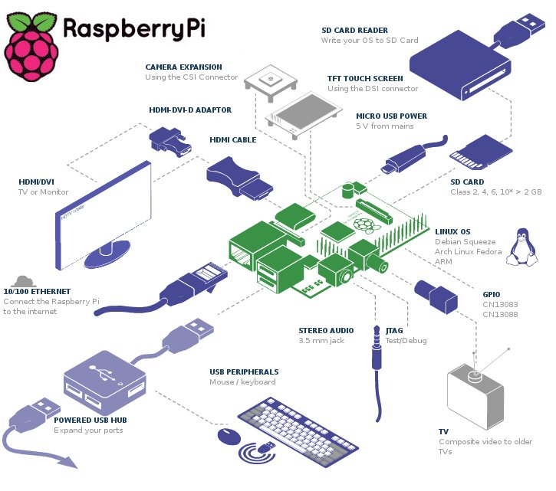

RFID Tag

GPS /GPRS

Raspberry PI 2

Wearable device

Heart Monitor

Temperature Monitor

*Amazon Web* Services

Data Base

Monitor \Laptop

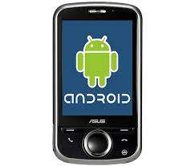

Heart rate and temperature data can be analyzed



**Figure1. Proposed Architecture for monitoring Health Care.**

**CONCLUSION**

The system that we have proposed is light weight and can be used on a daily basis and will help in quick recovery. we presented an approach for Alzheimer patient tracking using the RFID tags and the GPS. We presented a system allowing to have the relative position of the tag. Additionally we described how we can locate using the advantage of each technology. We furthermore present how to fabricate both of the elements: the tag and the reader. Finally, in practical our system can at the same time detect and build accurate maps sending data continually, otherwise knowing the position in real-time of people with Alzheimer disease.

We are monitoring temperature and heart beat continuously .Based on the threshold value sms goes to family member and doctor along with location also. By sending an Email alert to the doctor along with the GPS position of the user it ensures that the user receives immediate care.

**REFERENCES:**

[1] F. Klaus. Radio- Frequency Identification Fundamentals and Applications, New York, 2000.

[2] CNRFID (Centre National de Reference). Available: <http://www.centrenational-rfid.com>.

[3] OAT XERAFY. Available: <http://www.xeraf)r.com/userfiles>.

[4] Alzheimer's Foundation of America, "Lost and . . . Found", America, June.2012.

[5] Adriano. Available: http//www. arduino.cc/.

[6] F43 M4 Dry Inlay Data Sheet, Jump Technology Inc., America, 2013.

[7] 15_23_IEEE_Automated Health Alerts Using In-Home Sensor Data for Embedded Health

Assessment.

[8] 15_27_IEEE_Wireless Sensor Network System using Raspberry Pi and Zigbee for

Environmental Monitoring Application.

[9] 15_33_IEEE_A Smart System Connecting e-Health Sensors and the Cloud.